Conditions for submission of scripts 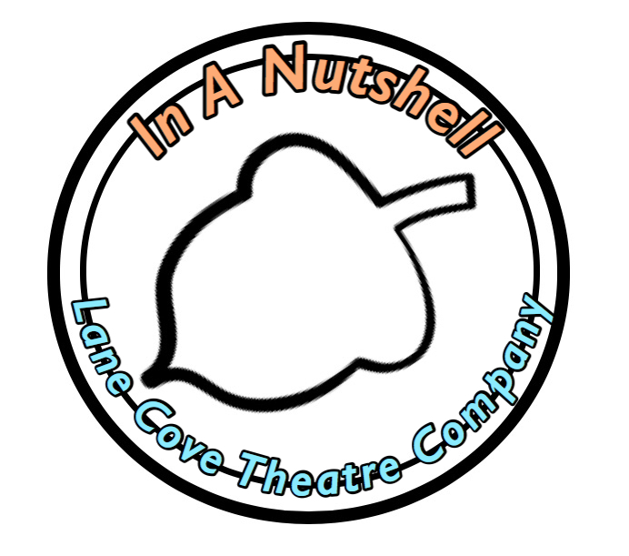
Before submitting your script to Lane Cove Theatre Company (LCTC) "In a Nutshell" please read the notes below and agree to our Terms and Conditions:
NOTES:
(i) Script refers to an original work submitted by the author. This can be spoken, musical or choreographed works.
(ii) A ten minute play is approximately ten pages when using proper script format. Please read it aloud and time it before submitting it.
(iii) LCTC may be able to put you in touch with directors available to direct your play if you do not have a director in mind. If a suitable director/writer relationship cannot be reached the script will not be considered and the administration fee forfeited.
(iv) LCTC will have a call out for actors who will be available to audition for plays in this festival. An audition day for directors will be held in Lane Cove on Sat 27 July (or another suitable date).
(v) Lighting and sound cues, as well as costumes, set and props should be kept to a minimum. Bear in mind that whatever is used in the play has to come on and off the stage in a short space of time (approx 30 secs). Ten minute plays focus on the dialogue and the actor rather than complex staging and effects.
(vi) The title of the script and page number should be included on each page.
(vii) Privacy - The personal information that you provide on your entry and your script will only be used by LCTC. Your personal information may be used to communicate with you about LCTC "In a Nutshell" and other LCTC related activities. You can opt out of these communications at any time by responding to any emails received with "Unsubscribe" in the subject line or the body of an email.
(viii) LCTC will only select one script per playwright for the current season of "In A Nutshell" - any other scripts may be resubmitted for future years.

AGREEMENT
- As the creator/writer of the script I give permission for Lane Cove Theatre Company to present my work at the 2019 "In a Nutshell" short play festival. I have also gained the permission of any co-writers to present this work.
- The performance time of this work is 10 minutes or less and I understand that if it is longer it will not be considered and the administration fee will be forfeited.

- I intend to direct this work myself or have sourced a director for this work and he or she will ensure that it does not exceed 10 minutes.
- As the writer/director I understand that I am ultimately responsible for sourcing appropriate talent.
- If my script is selected for LCTC "In a Nutshell" I am aware that I will not receive royalties for those performances but will be eligible for the People's Choice Award at the end of the showcase.
- In order for scripts to be assessed anonymously - in the interests of fairness and objectivity - I will ONLY put my name on the title page of the script. I understand the administrator will then remove this reference before sending my script(s) on to the assessors. I recognise that this includes not using my name as part of the document's filename.
- I will submit my script in Microsoft Word format.
- If my work is performed at the festival, LCTC will have the right to film/record/photograph it for marketing and publicity purposes (both for this and future festivals). This also includes archival, marketing or publicity purposes in an unpaid public forum such as YouTube.

Script title ____________________________________________________________
Please PRINT your full name ____________________________________________________________

Signature __________________________________ Date ____________________

